

Name___________________________________. Mark= /43

|  |  |  |
| --- | --- | --- |
| Test part | Possible mark | Your mark |
| Multiple choice | 10 |  |
| Short answer | 27 |  |
| Extended answer | 6 |  |
| Total | 43 |  |

HUMAN BIOLOGICAL SCIENCE. YEAR 12. 2011.

Inheritance and Gene Expression Topic Test.

***Multiple choice answer sheet.***

**Use a ball point or ink pen to mark an X** on the letter that represents the best answer from the choice of answers . Marks are not deducted for wrong answers.

|  |  |
| --- | --- |
| Question | Answer |
| 1 | A B C D |
| 2 | A B C D |
| 3 | A B C D |
| 4 | A B C D |
| 5 | A B C D |
| 6 | A B C D |
| 7 | A B C D |
| 8 | A B C D |
| 9 | A B C D |
| 10 | A B C D |

Multiple Choice Questions

1. Evidence of a gene being polygenic is:
2. A narrow range of phenotypes in the population.
3. Continuous graduation of the characteristic.
4. Inconsistent graduation of the characteristic.
5. There is no evidence.
6. Here are a number of possible genotypes for skin colour.
7. AABBCC
8. AaBbCc
9. AABBCc
10. AABbCC

Which genotypes will give the same phenotype?

1. I and II.
2. I and IV.
3. II and III.
4. III and IV.
5. Two carnations (flowers), a red one and a white one, are crossed and the second generation of offspring have three different genotypes. If this gene shows incomplete dominance, what is the color of the heterozygous plants?
6. Pink
7. Red
8. White
9. Brown
10. In dogs, gum coloration is co-dominant, with black being co dominant to pink. You have a lovely black and pink spotted gummed Labrador retriever who has just had 8 pups. Four of the pups have spotted gums like your dog, and 4 have pink gums. What is the likely phenotype of the sneaky neighbor dog?
11. Black
12. Pink
13. Spotted
14. Orange
15. Which of the following is correct?
16. A codon is group of 3 nucleic acid bases coding for one amino acid.
17. A codon is group of amino acids that combine to make a protein.
18. A codon is a length of DNA found in a structural Gene that codes for one protein.
19. A codon is a length of Transfer RNA.
20. **Use the diagram below to answer the question that follows.**

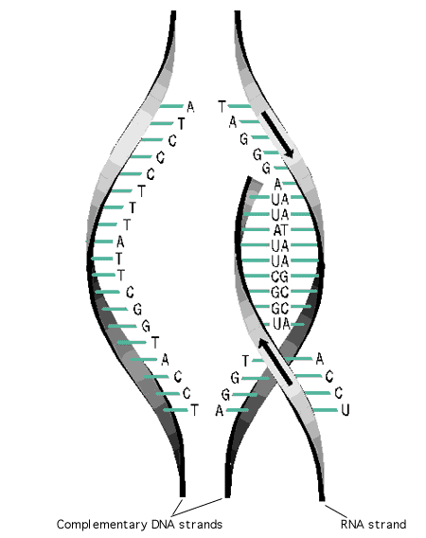

This diagram shows the process of:

1. RNA Translocation.
2. DNA Translocation.
3. DNA Transcription.
4. DNA Translation.
5. Which of the following statements is correct?
6. A promoter region is a length of DNA downstream from a structural gene.
7. A promoter region is a length of DNA upstream from a structural gene.
8. An operon is a length of DNA found in the cells of higher organisms, such as humans. It is made of a structural Gene and an operator gene.
9. A metronome is a length of DNA found in the cells of higher organisms, such as humans. It is made of a codon and an operator gene.
10. Which of the following is NOT true about an promoter region?
11. It acts like an “Off and on switch”.
12. It is attached to a structural gene.
13. It is found only in cells with a definite nuclear membrane.
14. It is available for RNA polymerase to bind to in all cells of the body.
15. Which of the following is TRUE?
16. Melanin is made in melasome tissue by melanocytes.
17. Melanin is made in Melanocytes by melasome organelles.
18. Melanin is absorbed from the sun.
19. Melanin production stops in winter.
20. Kevin is blood type AB. This means that he can accept blood donated by people who are blood type:
21. AB only.
22. O type only.
23. A type or B type.
24. Any blood type.

Short Answer Question.

Please answer these into this booklet.

1. A man who has blood type AB marries a woman who is blood type O. What proportion of the couple’s offspring could donate blood to their mother? Show all working.

(5 marks)

1. Coat colour in cattle shows Co-dominance. There is one allele giving white coat colour (W) and one allele giving Red coat colour(R). The heterozygous colour is called roan. Roan is a mixture of the White and Red colour. A Roan Cow is mated with a Roan Bull. What are possible proportions of the genotype and phenotypes of the offspring? Show all of the working.

(4 marks)

1. Protein synthesis involves two main stages, transcription and translation. In the table below outline the key points associated with each stage.

(6 marks)

|  |  |  |
| --- | --- | --- |
|  | Transcription | Translation |
| Where it occurs in the cell |  |  |
| Main event that occurs during the stage |  |  |
| Type/s of RNA involved in the stage |  |  |

1. Complete this table.

|  |  |
| --- | --- |
| Material | Function |
| Transport RNA |  |
| Messenger RNA |  |
| RNA polymerase |  |

(3 marks)

1. Complete the following sentences.

Epigenetics is where an individual’s DNA sequence is _________ , but the expression of certain alleles is ___________. This change in expression in one individual can be _________ by their offspring. Sometime molecules known as ________ groups from the environment can bind to the DNA. These groups can alter gene expression. Sources of these groups can be ______, household ________ and ______. This process is called DNA ___________.

Study of epigenetics is important because it is believed that some epeigenetic changes can lead to __________.

(9 marks)

EXTENDED ANSWER QUESTION

1. Phenotype is not just the result of Genotype. Explain three examples of the phenotype being impacted on by the environment.

(6 marks)

___________________________________________________________________________________________________________________________________________________________________________________________________________________________________________________________________________________________________________________________________________________________________________________________________________________________________________________________________________________________________________________________________________________________________________________________________________________________________________________________________________________________________________________________________________________________________________________________________________________________________________________________________________________________________________________________________________________________________________________________________________________________________________________________________________________________________________________________________________________________________________________________________________________________________________________________________________________________________________________________________________________________________________________________________________________________________________________________________________________________________________________________________________________________________________________________________________________________________________________________.